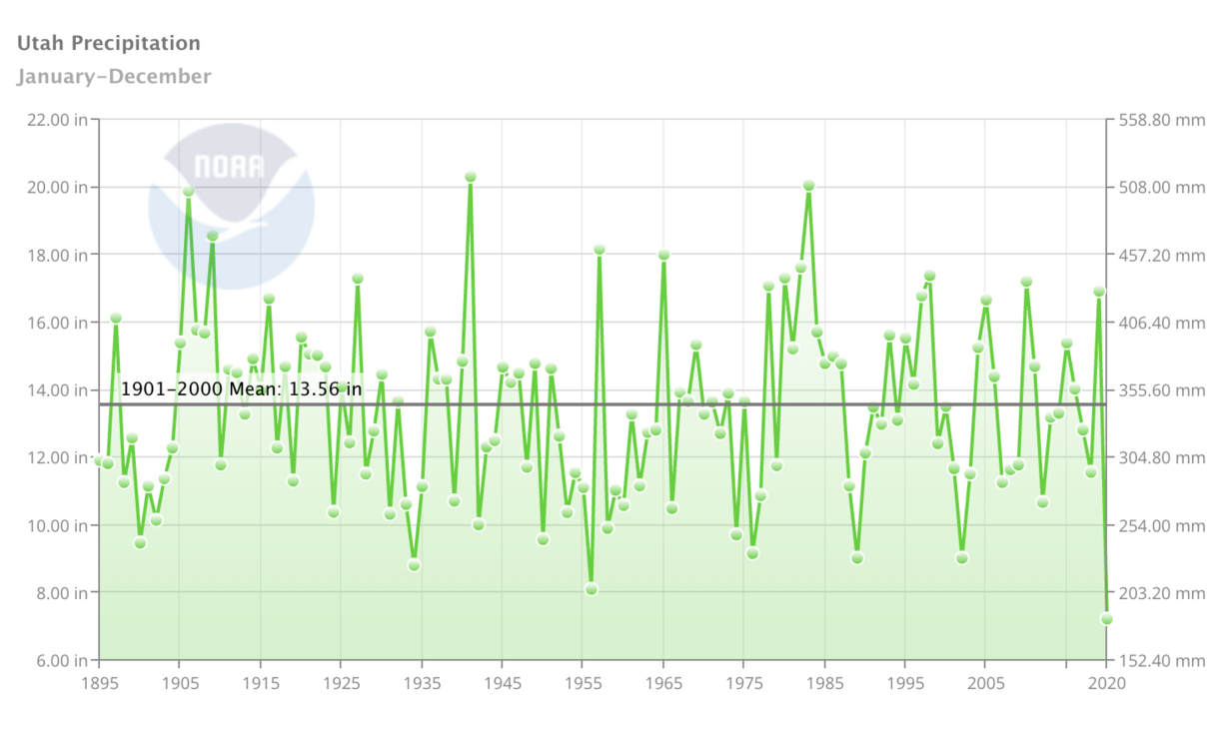
This graph shows Utah precipitation levels from 1895 through 2020. The graph shows the many extremes in state levels every year. (Photo: NOAA National Centers for Environmental information)

Website --
https://www.ksl.com/article/50201168/is-this-the-worst-drought-in-utahs-history-heres-what-the-science-and-data-say

